**File system hierarchy**

* /root-contain all other directories and files.
* /bin- Essential binary files which are accessible to all files. These files are prepared for basic functioning and for various system operations and user interactions.
* /boot-Files prepared for boot process include Kernel, boot loader and initial RAM disk. We want to load the os and prepare the system for use. All files prepared for booting are stored in boot directory.
* /dev-Device files representing the physical and virtual devices such hard drivers, printers, CPU.
* */etc* - System configuration files for various applications and services .Configuration files determines the behavior fuctionality and appearance of the software
* */home* - It is the home directories for the regular users
* */lib -* Libraries required by binary in /bin
* /mnt ,/media - temporary mounted files
* /mnt -temporary attaching file system. For eg external drives ,network shares ,external drives ,network shares.
* /media - Removable media it is a temporary mount system for removable media for eg USB , external hard drives.
* /sys- exposes information about system hardware and devices.
* /tmp - temporary files created by users and applications
* /usr - Basically user program and libraries.
* /var- variable data that changes frequently such as log files and cache files.

sudo su



tree

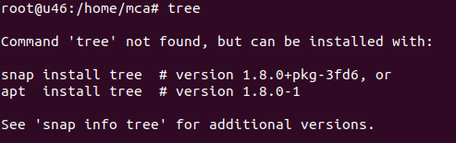

apt update

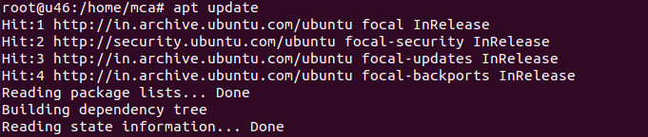

apt install tree

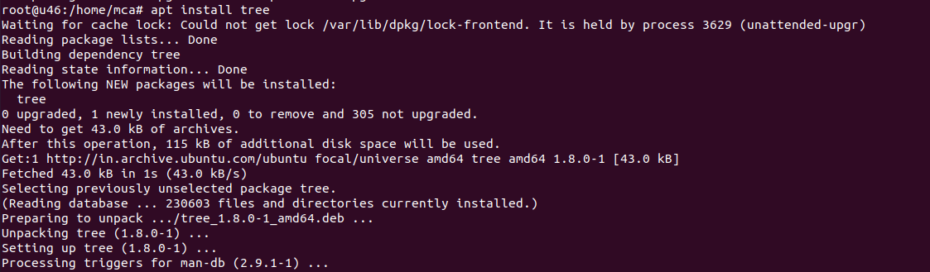

tree

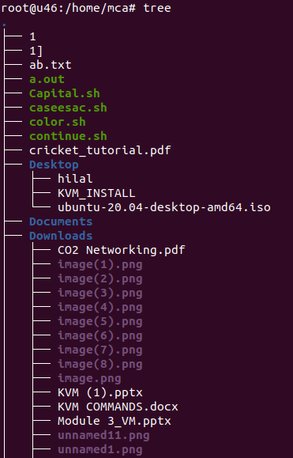

tree /bin

